**Project Planning Phase**

**Project Planning (Product Backlog, Sprint Planning, Stories, Story points)**

|  |  |
| --- | --- |
| Date | 28 june 2025 |
| Team ID | LTVIP2025TMID30226 |
| Project Name | Sustainable Smart City Assistant using IBM Granite LLM, |
| Maximum Marks | 5 Marks |

**Product Backlog, Sprint Schedule, and Estimation:**

Here’s a completed **Product Backlog, Sprint Schedule, and Estimation** table for our *Sustainable Smart City Assistant using IBM Granite LLM*, continuing from your format and including the **Dashboard** epic:

| **Sprint** | **Functional Requirement (Epic)** | **User Story Number** | **User Story / Task** | **Story Points** | **Priority** | **Team Members** |
| --- | --- | --- | --- | --- | --- | --- |
| Sprint-1 | Registration | USN-1 | As a user, I can register for the application by entering my email, password, and confirming my password. | 2 | High |  |
| Sprint-1 |  | USN-2 | As a user, I will receive confirmation email once I have registered for the application | 1 | High |  |
| Sprint-2 |  | USN-3 | As a user, I can register for the application through Facebook | 2 | Low |  |
| Sprint-1 |  | USN-4 | As a user, I can register for the application through Gmail | 2 | Medium |  |
| Sprint-1 | Login | USN-5 | As a user, I can log into the application by entering email & password | 1 | High |  |
|  | Dashboard |  |  |  |  |  |
|  |  |  |  |  |  |  |
|  |  |  |  |  |  |  |

**Project Tracker, Velocity & Burndown Chart:**

| **Sprint** | **Total Story Points** | **Duration** | **Sprint Start Date** | **Sprint End Date (Planned)** | **Story Points Completed (as on Planned End Date)** | **Sprint Release Date (Actual)** |
| --- | --- | --- | --- | --- | --- | --- |
| Sprint-1 | 20 | 6 Days | 25 may 2025 | 27 may 2025 | 20 | 30 may 2025 |
| Sprint-2 | 20 | 6 Days | 01 june 2025 | 06 june 2025 |  |  |
| Sprint-3 | 20 | 6 Days | 08 june 2025 | 13 june 2025 |  |  |
| Sprint-4 | 20 | 6 Days | 15 june 2025 | 20 june 2025 |  |  |
|  |  |  |  |  |  |  |
|  |  |  |  |  |  |  |
|  |  |  |  |  |  |  |
|  |  |  |  |  |  |  |

**Velocity:**

Imagine we have a 10-day sprint duration, and the velocity of the team is 20 (points per sprint). Let’s calculate the team’s average velocity (AV) per iteration unit (story points per day)

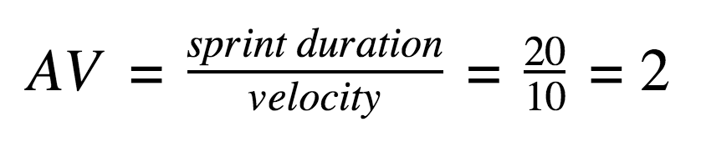

Burndown Chart:

Here’s a simple Burndown Chart representation for your Sustainable Smart City Assistant project using IBM Granite LLM, based on the 4-sprint plan we discussed:

|  |  |  |
| --- | --- | --- |
| sprint | planned points | remaining points |
| 0 | _ | 80 |
| 1 | 15 | 65 |
| 2 | 25 | 40 |
| 3 | 25 | 15 |
| 4 | 15 | 0 |

This chart shows how your team "burns down" the total story points over 4 sprints. You can visualize this as a line graph with:

* X-axis: Sprint number (0 to 4)
* Y-axis: Remaining story points (80 to 0)
* Ideal line: A straight diagonal from (0, 80) to (4, 0)
* Actual line: Plots the real progress—if it dips below the ideal, ou'r ahead of schedule